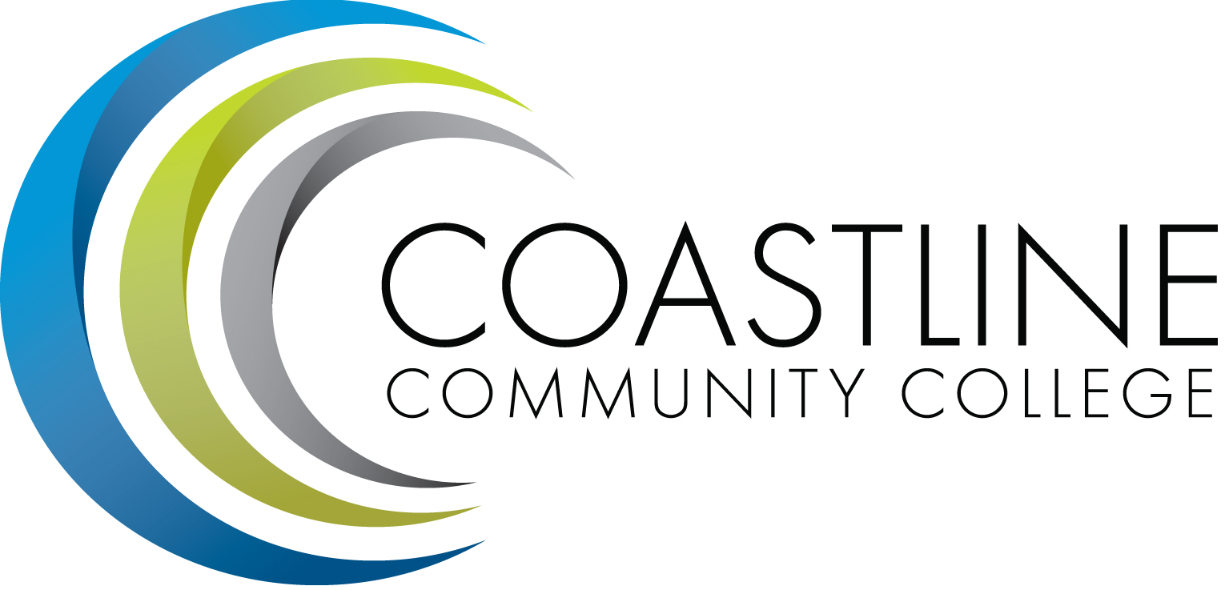
Coastline Management Meeting (CMT) Minutes
September 5, 2017
9:00 – 11:00 a.m.
4th Floor Conference Room

Name | Present | Name | Present | Name | Present
Adrian, Lori | X | Emerson, Dana | X | Miyashiro, Ross | X
Akins, Renate | X | Garvey, Judy | X | Nash, Bob | X
Barnes, Stephen | X | Groot, Joycelyn | EXC | Neal, Tom | X
Blair, Shelly | X | Gutierrez, Rene |  | Nguyen, Christine | X
Brais, Nathan | X | Harrison, Nate | ABS | Rodriguez, Vince | X
Cant, Dave | ABS | Jones, Nancy | X | Rothgeb, Helen | EXC
Capoccia-White, Rozanne | X | Keeler, Bruce | X | Sanchez, Jorge | X
Colver, Mike | X | Khosravani, Mariam | X | Scott, Michael | X
Dahnke, Lynn | ABS | Le, Mai | X | Thompson, Dave | X
De La Rosa, Jennifer | X | McDonald, Jennifer | X | Tran, Kathie | X
Donahue, Kevin | X | Mendez, Julie | ABS | Woodyard, Steve | X
 |  |  |  | Zentner, Aeron | X
Guests: Sasha Montero, Cindy Vyskocil, Crystal Crane
Recorder: Martha Tran-Nguyen
Transcriber: Kathy Surgenor
(NOTE: Recorder started at CFCE presentation; therefore, Minutes and Agenda items were not addressed. Not sure if approvals were voted upon)

- CALL TO ORDER
  - Roll Call
  - Welcome – Dr. Adrian introduced guests to the committee and welcomed a new Team member, Kathie Tran from Financial Aid.
  - Adoption of Agenda **Agendas (w/amendments)
  - Approval of Minutes
- May 2, 2017
- July 19, 2017 ( Special CMT Meeting)
- August 1, 2017
  - “Pride Club” presentation – K. Donahue, S. Montero (5 mins) – Sasha Montero discussed the Pride Club and discussed the Safe Zone Training that was completed and how the “Pride Club” was formed as a result of that training. Sasha and Kevin are co-advisors. Currently there are seven (7) members of the Club. The Club will make an appearance at all 3 campuses to inform students and others of its existence. The primary mission of the Club is to raise awareness about LGBTQ issues within the community and to create safe environments for students. Additional safe zone training will be provided on the first four Fridays of October and again in the spring. More information is forthcoming about the training. Kevin mentioned that the next meeting of the Pride Club will be held on Monday, September 11 at 3:30pm in Room 320 at the Newport Beach Center. All those interested are welcome to attend. All managers are urged to attend.

- ACTION ITEMS - None

- STANDING REPORTS (2 minutes per)
3.1 Accreditation – V. Rodriguez – Danny Pittaway has been in the process of reviewing all Accreditation items being submitted to ensure accuracy and he will provide a summary in the near future. It is imperative that all reports are completed this year. Vince and Dr. Adrian emphasized the importance of posting Minutes and Agendas prior to meetings. Dr. Adrian suggested that the Standards should be reviewed in the CMT meetings. She mentioned the availability of the Accreditation Basics Online Training on the ACCJC website. Dr. Adrian encouraged all members to take advantage of this training. She discussed work she and Vince are doing for the Accreditation visit to Modesto Junior College. Dr. Adrian requested that “documentation of broad based dialogue regarding student achievement” be added to all committee meeting agendas as a Standing Report item. Aeron and Vince discussed information provided in Program Review meetings to that end and suggested additional ways in which to share information. Vince and Danny will provide a report and summary of the completed Standards work to date at the next meeting.
3.2 PIEAC – S. Barnes, V. Rodriguez – Dr. Adrian recommended discussion take place with regard to the Scorecard, Accreditation, and student achievement in PIEAC meetings.
3.3 Budget – C. Nguyen – No Report
3.4 Academic Senate – S. Barnes – The first meeting will take place today wherein the Professional Development Strategic Plan, Enrollment Management, and Senate goals will be discussed and reviewed.
3.5 Classified Senate – K. Donahue – Kevin expressed gratitude to Dr. Adrian on behalf of the Classified Senate for time spent with them during the All-College Meeting. He requested morning meetings in the future.
3.6 Associated Student Government (ASG) – N. Brais – ASG will meet every Friday morning. Two movie nights have been planned. Club Rush will be conducted this Wednesday and Thursday (at all 3 Coastline sites) to provide information on existing clubs and how to establish new clubs. The ASG retreat was held on August 21-23. Carlos, ASG President, expressed thanks to all those who attended the student lunches on those dates.
3.7 President’s Report – L. Adrian – Dr. Adrian discussed **Appreciative Inquiry and Guided Pathways. She expressed that based upon feedback, a clear definition of Guided Pathways needs to be provided. She elaborated on the definition and intent of Appreciative Inquiry and Guided Pathways and advised that a book could be purchased for members and a training could be scheduled in order to provide more information on these topics. Aeron and Ross provided information about the Guided Pathways process and a best practices approach. Dr. Adrian announced that Coastline will recruit for a new Dean of Students and Equity (with assistance from the VC of HR). In the interim, a part-time person will be sought to fill in for that position as well as the VP of Student Services position until permanent appointments have been made for both positions.
  - Executive Team Report – J. Groot, R. Miyashiro, C. Nguyen, V. Rodriguez
- J. Groot – Rozanne Capoccia-White reported that corporate enrollments increased significantly from last year; military enrollments have declined due to factors beyond our control, including transition by Navy to a virtual education center, and lack of access for advising on Navy installations. They are assessing other options. Jennifer De La Rosa reported that four (4) certificates have been selected by Service Member Opportunity Colleges, and a few others by Army University as preferred programs. We anticipate these acknowledgements will improve enrollments.
- R. Miyashiro – The Starfish program, an early alert system, was launched this week. Dr. Keeler will serve as lead for this initiative. Two meetings have been scheduled to be held this week: 1) technical kickoff meeting, and 2) functional users’ kickoff meeting.
- C. Nguyen – Dr. Adrian reported that she and Christine will meet with the Chancellor this afternoon to discuss the College Center renovation. Le-Jao is open and operational and student input has been very positive. Newport Beach added new furniture to enhance its environment. Christine announced that year-end closing figures have been delayed; therefore, the accounting process for all categorical and grant programs are being reviewed, including positions and functions within various departments. The District is also reviewing the current allocation model. She will provide updates as they are received. The first Administrative Services Training will be held on September 22 from 8:30a-12:30p on the 4th floor for new employees and new training manuals will be provided. Dr. Adrian encouraged all members to attend.
- V. Rodriguez – Enrollment figures reflect a positive outlook. Estimated FTEs have increased and all efforts will continue to maintain this trend. The average Coastline class size is the largest in the District. Dr. Adrian reported that CC is currently 400 over base; Vince interjected that percentages could go up to 5-6% over base by spring.
3.9 HR Report – R. Akins – Renate reminded that Shaunick Barber’s primary responsibility is recruiting and worker’s compensation injury issues. Contract and Employee Relations issues should be submitted and discussed with Renate directly. In addition, request for information should be submitted in the form of an E-mail request opposed to requesting in person. For recruitment issues, contact Shaunick and for HR issues, contact Renate.
3.10 Financial Aid Federal Program Review Update – Dr. Adrian advised that two (2) reviews must be completed: 1) for the state regarding LDA (Last Day of Attendance) and no shows data (due within 45 days), and 2) return to Title IV (federal issue). Dr. Adrian advised that every faculty member should be contacted via phone calls in order to emphasize the importance of reporting this information promptly and accurately. DOE audits continue for Financial Aid issues because of reporting problems. She requested that the Instructional Division create a script to be utilized for phone calls being made. Stephen Barnes suggested that a text message be sent out to all faculty members advising them of the current reporting process. Dr. Adrian urged deans and managers to support this effort. She added that this issue must be resolved by or before March 2019 in order to prevent future Accreditation issues. Currently Financial Aid disbursements are also an issue due to transition to Banner Financial Aid. Dr. Adrian reminded all that a book voucher system is available for students whose financial aid disbursements are delayed.
- DISCUSSION ITEMS
4.1 All-College Meeting – No Report
4.2 Vacation Planning – V. Rodriguez – No Report
4.3 Online College – Dr. Adrian reported that a proposal for a new collaborative on-line college model was completed and stated that copies of the proposal would be provided to all members. Ross provided a report about the FLOW meeting he recently attended and described presentations he and other attendees provided at the meeting. He discussed a comparison analysis of other college program models vs. Coastline’s program models based upon presentations made by the other colleges. A lengthy discussion ensued.
4.4 College Scorecard (A. Zentner) – Aeron distributed copies of the **2016-17 KPI Scorecard Results and described the purpose of the Scorecard and discussed the focus and progression of college goals. Based on Scorecard results, student success and retention rates have increased and Coastline has achieved a higher performance average. Dr. Adrian suggested that additional KPIs be added to the Scorecard and to include student matriculation data. She advised members to share the Scorecard with their constituents /staff. Dr. Adrian and Jorge Sanchez discussed how Standards are set.

- SPECIAL REPORTS & UPDATES
5.1 CFCE Update on Salary and Retirement (C. Vyskocil) – Vice Chancellor of HR provided a report of the CFCE Agreement. She stated that Reclassification Process part of the Agreement was completely revised. She advised and explained that since the Agreement was ratified late in the reclassification window; the deadline for submission of reclassification requests was extended through the end of October vs. the end of September for this year. Crystal Crane interjected that the reclassification process is separate from the class & comp re-evaluation process which will be available to employees with the implementation of the studied. Dr. Vyskocil elaborated on the processes. She explained that a new longevity structure has been designed for classified, confidential and management employees. The benefit payment structure has been revised effective October 1.For classified, confidential and management employees .08% vs. .05% will be deducted from paychecks, 10 months per year, to go toward benefit premiums. Substantial changes have been made to Short-term and Long-term disability benefits for classified staff. She explained all changes to this Benefit. Retiree benefits have been revised; Delta Health PPO will no longer be available to new Retirees after December 31, 2017.HMO benefits will not be affected. The custom designed United Health Care Medicare Supplement PPO for our District will continue to be available to Retirees. This new CFCE Agreement is a two-year agreement; therefore, anyone hired after January 1 must have 15 years of service with the District and must be age 60 in order to be eligible for retirement with medical benefits. The significant change is the age requirement of 60 instead of 55.In addition, a $3,000 subsidy will be provided to employees for the UHC plan premium instead of $4,000 after age 70.A question and answer session was provided to the committee following the Vice Chancellor’s report. A successor Agreement will be negotiated for 2018-2019.Dr. Vyskocil discussed requirements for the reorganization process and provided details about the process.

- HOT TOPICS

- ANNOUNCEMENTS
  - SE/BSI/SSSP Funding Request Application: Due September 11, 2017.
  - Dr. Adrian announced that Ross has resigned from Coastline effective September 14 and has accepted a position as Vice President of Student Services at El Camino College. A joint reception will be held on September 8 sponsored by Student Services and the President’s Office. More information will be forthcoming ASAP.

- ADJOURNMENT – Meeting adjourned at 11:00 a.m.
- CDMA – CLOSED SESSION

- SUMMARY OF KEY ITEMS DISCUSSED/ACTIONS TAKEN
10.1 Pride Club presentation
10.2 Accreditation
10.3 Guided Pathways
10.4 Financial Aid Federal Program Review Update/Process Reminders
10.5 Online College
10.6 College Scorecard
10.7 CFCE Update on Salary and Retirement

Documents Distributed:
- Guided Pathways (2 handouts)
- 2016-17 KPI Scorecard Results

Next Meeting: Tuesday, October 3, 2017, 9:00 a.m., 4th Floor Conference Room
*Attachment emailed
**Attachment provided at meeting

